Community Question Answer (CQA) website

【Abstract】
The Community Question Answer (CQA) website solves users' online questions, timely answers, centralized management of information and quick queries.
The system uses B/S micro-service SpringBoot structure, MVC framework as the development platform, java running environment, mysql as the background database, Redis cache, and Eclipse as the development tool for development.

contents
Chapter I Introduction 1
1.1 Instructions 1
1.2 Overview 1
Chapter II System Planning 1
2.1 Functional requirements analysis 1
2.2 feasibility analysis 2
2.3 Key technologies and complexity analysis to be adopted in system design 3
2.4 SpringBoot microservice framework 3
2.6 Mybatis data persistence framework 5
Chapter III System Analysis and Design 6
3.1 Identify participants 6
3.2 Identify use cases 6
3.3 Architecture of system design 6
3.4 System functional structure design 7
3.5 Detailed design of system community question and answer (CQA) function 8
3.6 System database design 8
4.4 System operation environment and development tools 8
4.4.1 System operation environment 8
4.4.2 development tool 9
Chapter IV System Implementation 10
5.1 Create the database cqadb. The screenshot is as follows:： 10
5.2Login function 10
5.3 Question and answer (CQA) query 11
5.4、The screenshot of the user's question is as follows： 12
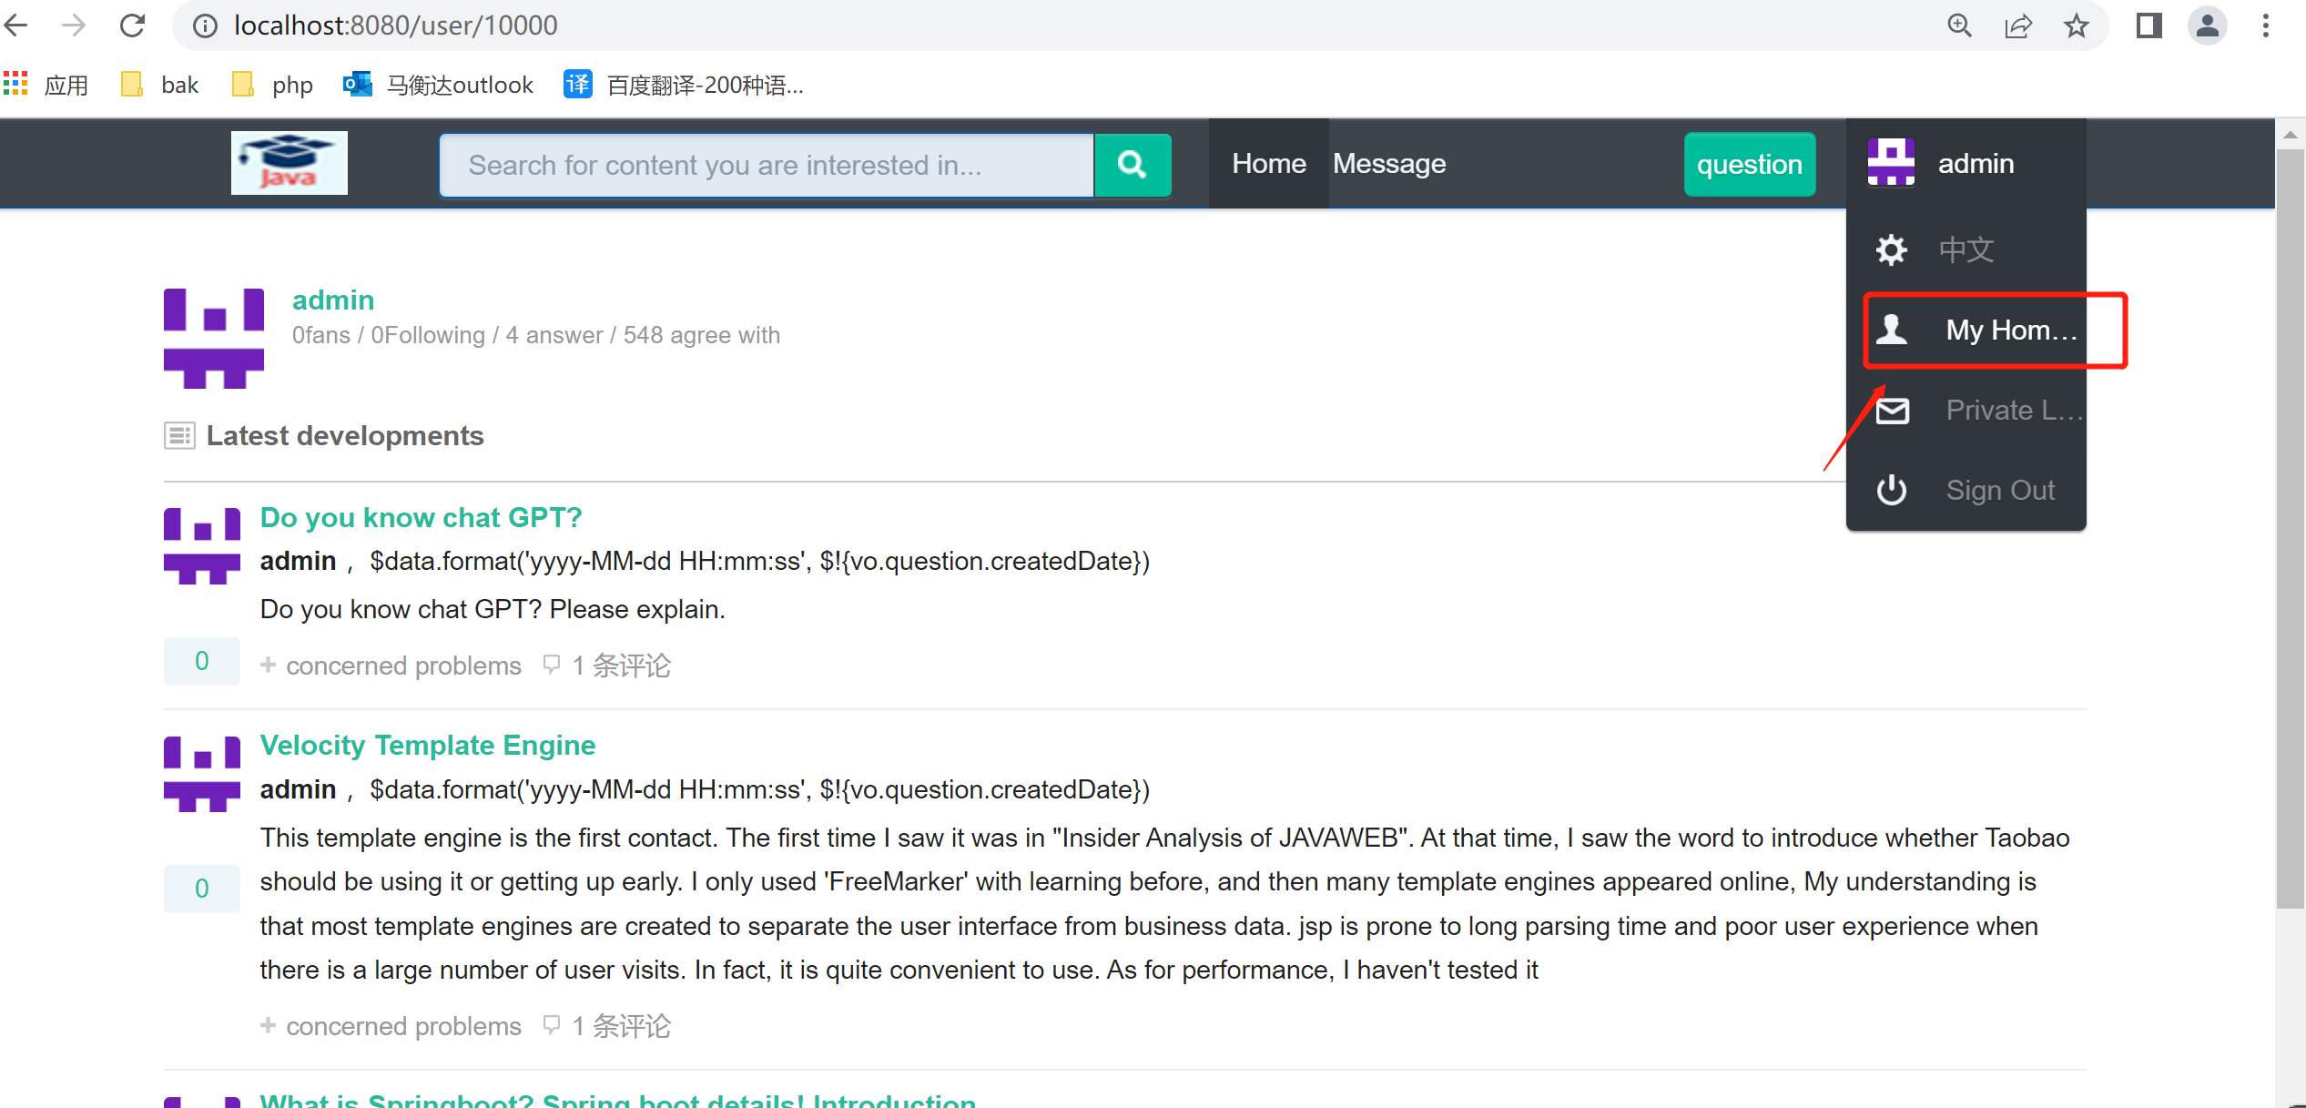5.6 Support the realization of Chinese/British internationalization 13
Chapter V Performance Test 14
6.3 Example test 16
6.4 Test Summary 16
Chapter VI Conclusion 17
Thank you 18

Chapter I Introduction

1.1 Instructions
There is no constraint on which tools or programming language you use. We are only interested in the end-product that you deliver. You should design your application in such a way that it is user friendly, has good performance, and is secure.
Please don’t use any existing CQA software. You need to develop it yourself.

1.2 Overview
In this assignment you will learn how to design a web based application that will allow users to interact with databases in a user-friendly manner. Your application will have a web based user interface at the frontend, and will have an interface with a database at the backend.

You will develop a Community Question Answer (CQA) website. You will use a CQA dataset from StackExchange archive. Download the Software Engineering dataset. For converting the XML files into csv you may use this link. You can also see a sample SQL schema here.

Some useful links
- W3Schools
- Java Servlets (Java)
- Java Spring Framework
- Django Framework (Python)
- Django Tutorial
- Django Autocomplete

Chapter II System Planning

2.1 Functional requirements analysis
1.Create a database named cqadb. Create appropriate tables with constraints and then populate the tables using the above data dump.
2.Login - Create an account for each user with their default password being the same as their username. Users should be able to login to the system using username and password. Allow new users to create accounts. Use cookie to provide session to authenticated users. You can let the cookie be stored permanently. Demonstrate that after the user removes the cookie, the user is logged out of the system.?

3.Autocompletion Search - Support search of tag name and user display name using autocompletion. While showing the result, list both the name and id for tags and users.
4.Search Posts - Support the following three post search functionalities:
4.1.Search by user id - Given a user id list all the posts of the users. Allow sort by time, upvotes.
4.2.Search by single tag - Given a tag, list all the posts containing that tag. Allow sort by time, upvotes.
4.3.Search by multiple tags - Given more than one tag, list all the posts containing all the given tags. Allow sort by time, upvotes.
5.Create Posts -? A user can create a post and assign tags to them. The tags have to be one of the existing tags only. It would be useful if the user can be helped with the tagging process through autocompletion.??
6.Answer to Posts - A user can search for posts and give answers. The interface should show the posted question and all the answers.
7.Edit Posts:? A logged in user should be able to see all the posts the user has written. The user should be able to update the content/tags of their own post or even delete them.?。

2.2 feasibility analysis
Feasibility analysis, also known as feasibility study, is to analyze and study the development of the new system from the aspects of policy, environment and economy based on the investigation, aiming at the necessity and possibility of the development of the new system, in order to avoid investment mistakes and ensure the success of the development of the new system [1]. The purpose of the feasibility study is to determine whether the problem can be solved in the shortest possible time at the minimum cost [2].

2.3 Key technologies and complexity analysis to be adopted in system design
Java's platform-independent feature has attracted widespread attention [3]. The design of the system mainly adopts J2EE technology system, and uses layered idea to design the program. J2EE is a set of extended specifications for enterprise development using Java. It provides solutions for designing, developing, deploying and managing enterprise applications based on components. The enterprise application system based on J2EE is not bound by any specific operating system, network environment and hardware platform [4]. In addition to using JSP technically, this CQA system also uses SpringBoot、 Mybatis、 Redis、 and AJAX technologies。

2.4 SpringBoot microservice framework
SpringBoot is not an enhancement to spring, but a framework for rapid development using spring. The background is that with the popularity of dynamic languages (Scala, Groovy), Java language development is particularly cumbersome, cumbersome configuration, low development efficiency, complex deployment process and difficult integration of third-party technologies. In this case, SpringBoot is produced. It uses (habit is better than configuration). (There are a lot of configurations in the project. In addition, some custom configurations are built in, which greatly reduces our workload. Using SpringBoot can easily create a quasi-production project based on the spring framework that runs independently (running jar, embedded servlet container). Using SpringBoot, we can not even need a few spring configurations。

SpringBoot core functions
1. Independently running spring project
SpringBoot can be run directly in the form of jar packages, such as java - jar xxx.jar. The advantages are: save server resources
2. Embedded servlet container
SpringBoot can choose to embed Tomcat and Jetty, so we don't need to deploy the project in the form of war package.
3. Provide starter to simplify Maven configuration
For example, spring boot starter web will be imported automatically
4. Automatic configuration of spring
SpringBoot will automatically configure beans for classes in jar packages according to jar packages and classes in the class path, which will greatly reduce the configuration we need to use. Of course, SpringBoot only considers most of the development scenarios, not all of them. If we need to configure beans automatically in the actual development, but SpringBoot cannot meet the requirements, we can customize the automatic configuration.
5. Application monitoring of quasi-production
SpringBoot provides monitoring of runtime projects based on http, ssh and telnet
6. No code generation and xml configuration
Spring Boot makes extensive use of the new annotation features provided by spring 4. x to achieve code-free generation and xml configuration. Spring 4. x advocates the combination of Java configuration and annotation configuration, while SpringBoot can implement all spring configurations without any xml configuration.
SpringBoot makes development, deployment, monitoring and configuration easier.
advantage:
Quick Build Project
Seamless integration with mainstream frameworks
The project can run independently without relying on an external servlet container
Provide application monitoring at runtime
Greatly improve development and deployment efficiency
It is convenient to integrate with Docker container.
#, do user identity authentication;
#, do access control, such as:
#, whether this user is assigned a certain role;
#, whether this user has permission to do something;
#, you can use user session management in any environment, even without a web or ejb container;
#, you can integrate multiple types of user authority data (such as relational database, LDAP, etc.) into a user view interface;
#, support Single Sign On SSO;
#, support remembering secret services。

2.6 Mybatis data persistence framework
MyBatis, formerly known as iBatis, was originally an open source project of Apache. In 2010, this project was migrated from Apache software foundation to Google code and renamed MyBatis. MyBatis is an excellent persistence layer framework that supports common SQL queries, stored procedures and advanced mapping. MyBatis eliminates almost all the manual setting of JDBC code and parameters and the retrieval of result sets. MyBatis uses simple XML or annotations for configuration and raw mapping, and maps the interface and Java POJOs (Plan Old Java Objects, common Java objects) to records in the database.
The functional architecture of Mybatis is divided into three layers (the picture is borrowed from Baidu Encyclopedia):
1) API interface layer: interface APIs provided for external use. Developers use these local APIs to manipulate the database. Once the interface layer receives the call request, it will call the data processing layer to complete the specific data processing.
2) Data processing layer: responsible for specific SQL lookup, SQL parsing, SQL execution and execution result mapping. Its main purpose is to complete a database operation according to the call request.
3) Basic support layer: responsible for the most basic functional support, including connection management, transaction management, configuration loading and cache processing. These are common things, and they are extracted as the most basic components. Provide the most basic support for the upper data processing layer。

Chapter III System Analysis and Design

3.1 Identify participants
For the analysis of the functional requirements of the platform, we have positioned two participants: search user xxxxxx/123456 and administrator admin/123456. The participants are described as follows:
(1) Ask the user xxxxxx/123456
Description: You can log in to view your own file directory.
Example: common CQA system user.
(2) Administrator admin/123456
Description: Manage profile&questions (delete, etc.).
Example: users after login。

3.2 Identify use cases
Participants have been identified previously. Through further analysis of requirements, it can be determined that the following use cases exist in the CQA system:
(1) Login use case: This use case provides the function of verifying the identity of users and administrators.
(2) Browse use case: view the function of file directory。

3.3 Architecture of system design
The construction of this CQA system adopts the B/S architecture. In the B/S architecture system, users ask questions about the browser through the browser to the server (i.e. community) and return the questions to the browser [5]. The B/S structure simplifies the work of the client. Only a small amount of client software needs to be configured on the client. The server will take on more work, and the database access and application execution will be completed on the server. The browser sends the request, while the rest of the work such as data request, processing, result return and dynamic web page generation are all completed by the Web Server.

3.4 System functional structure design
Based on the analysis and investigation of the certification and implementation of the community question and answer (CQA) function, the overall plan of the certification and implementation of the community question and answer (CQA) function platform is formulated.
After analyzing the authentication and the business of realizing the community question and answer (CQA) function, users are classified into two categories. The functions used by each type of users are different. The following functions are specified to meet the needs of each user.
The foreground function of the community question and answer (CQA) system is to search questions, answer questions, and provide services for administrators. Its functional structure is shown in Figure 4.2.
Community Q&A system
Admin
User
User（all）manager
CQAmanager
User manager

CQA manager

Figure 4.2 Functional structure of CQA system foreground

The functions used by search users include community question and answer (CQA) system functions (including viewing authentication and realizing online question raising, problem solving, problem management, etc.)。

3.5 Detailed design of system community question and answer (CQA) function
Community question and answer (CQA) function

3.6 System database design
The community question and answer (CQA) system focuses on the interoperability with visitors and the operability of information resources, so the database is essential. Database is the latest technology of data management and an important branch of computer science [6]. The database serves all columns, and the database established should strive to be rigorous in structure, clear in relationship, and avoid redundancy. At present, the commonly used database management systems include Access, SQL Server, MySql, Oracle, etc. MySQL is a small and medium-sized relational database management system with powerful relational database creation, development, design and management functions. Because of its powerful function and convenient operation, it is suitable for users at different levels to master and use [7]. Therefore, this CQA system uses mysql database.
1. User table "user"
2. Q&A form "question"
3. Comment table "comment"
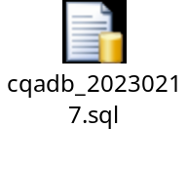

4.4 System operation environment and development tools

4.4.1 System operation environment
In order to ensure the efficiency and reliability of the community question and answer (CQA) system, the server side of the CQA system should have high software and hardware configuration, and the requirements of the client side are not very high. This community question and answer (CQA) system can be widely used on the Internet, that is, the Internet. Its operation requirements are as follows:
(1) Database: MySQL 5.7 or above
(2) JDK (Java Development Kit) version: above 1.8.0

4.4.2 development tool
This CQA system uses eclipse (integrated development environment) as the development tool. Eclipse is an open source, Java-based, extensible development platform. As far as it is concerned, it is just a framework and a set of services for building development environments through plug-in components. Fortunately, Eclipse comes with a standard set of plug-ins, including the Java Development Kit (JDK).
Although most users are happy to use Eclipse as a Java integrated development environment (IDE), the goal of Eclipse is not limited to this. Eclipse also includes the Plug-in Development Environment (PDE), which is mainly aimed at software developers who want to extend Eclipse, because it allows them to build tools that integrate seamlessly with the Eclipse environment. Because everything in Eclipse is a plug-in, all tool developers have the same place to play in providing plug-ins to Eclipse and providing users with a consistent and unified integrated development environment。

Chapter IV System Implementation

5.1 Create the database cqadb. The screenshot is as follows:：
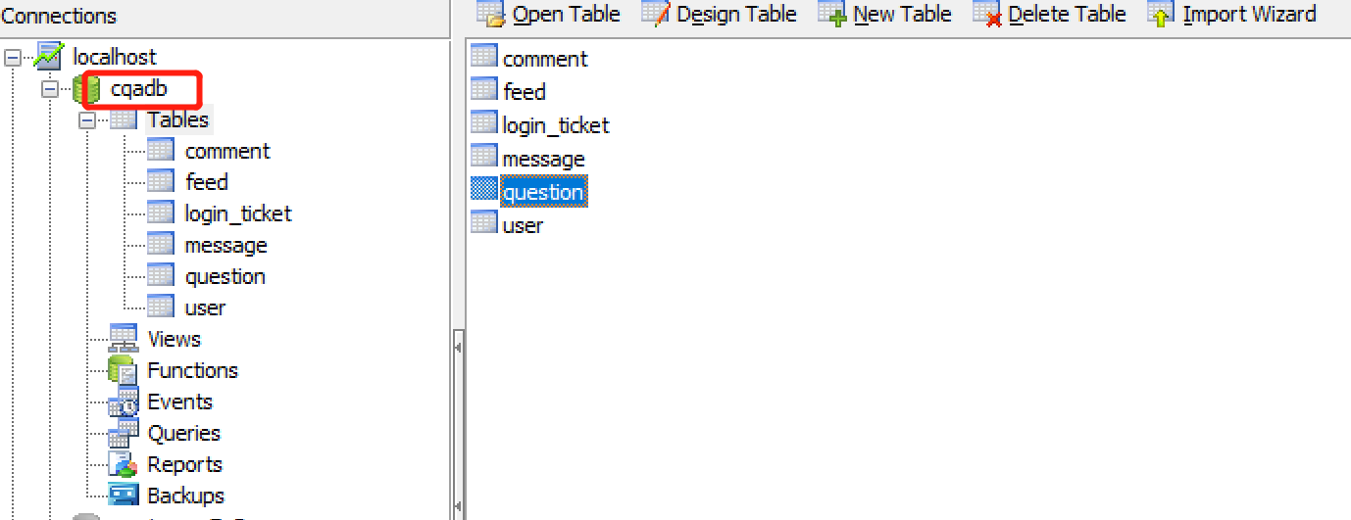

5.2Login function
In the administrator login interface, enter the user name in the text box corresponding to the user name and the password in the text box corresponding to the password. If the user name and password correspond to the user name and password in the database at the same time, click "OK" to enter the main interface of the system. If the information entered is incorrect, a prompt will be given.
Enter: User name and password.
Processing: check the validity of characters. The user needs to provide a user name and password to log in to the system. This is to verify whether the user meets the input requirements, that is, verify whether the user name and password text box is empty. If it is empty, the user will be prompted to enter the user name and password. Verify whether the user name exists or the password is correct, that is, whether the user name entered by the user exists and the password is correct.
Output: if the login is successful, enter the user's system use resource page. If the login is unsuccessful, the error information page will be displayed。

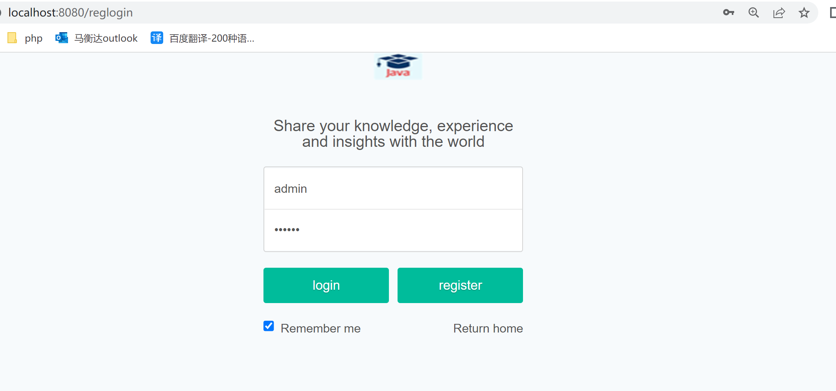

5.3 Question and answer (CQA) query
This function mainly includes the realization of the query&answer search function。
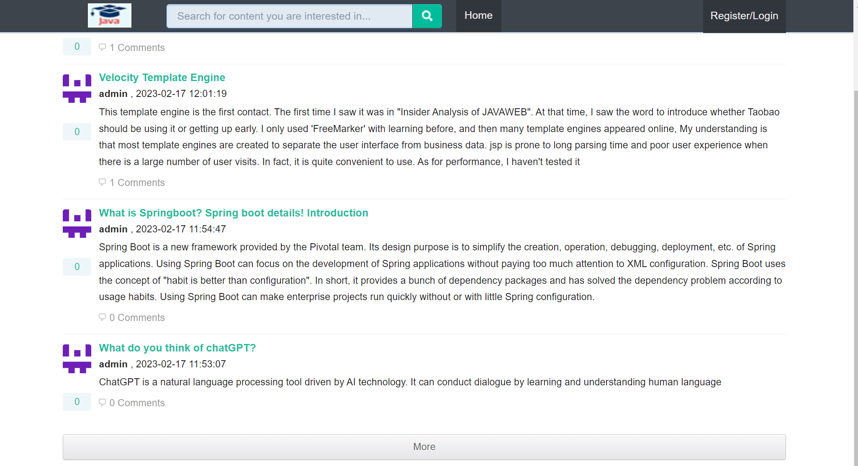

5.4、The screenshot of the user's question is as follows：
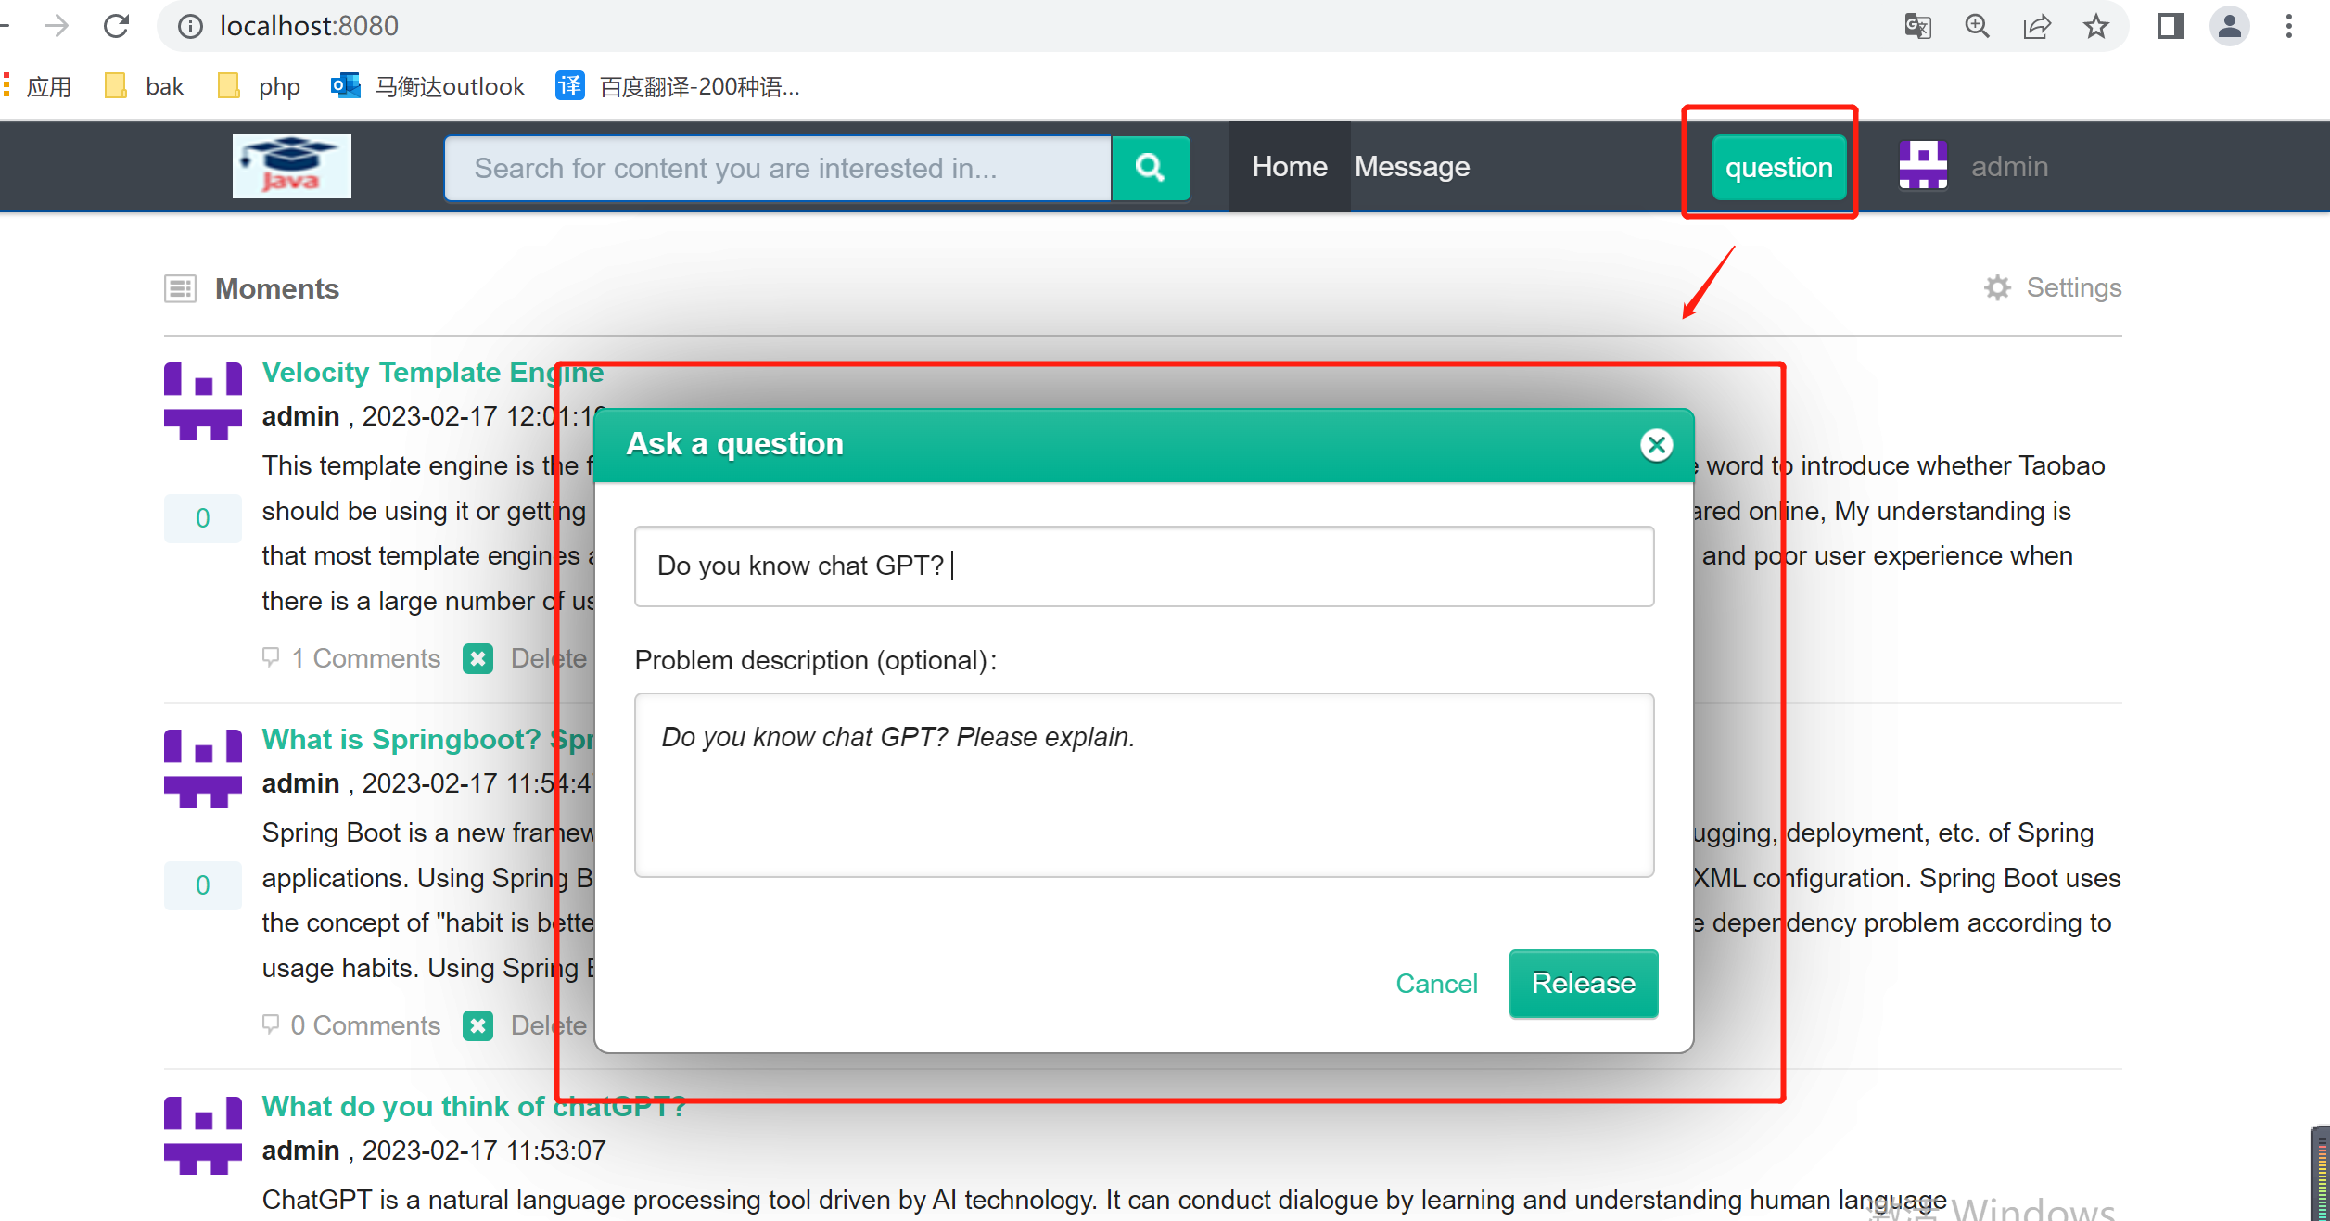

5.5 The screenshot of the user's answer is as follows：
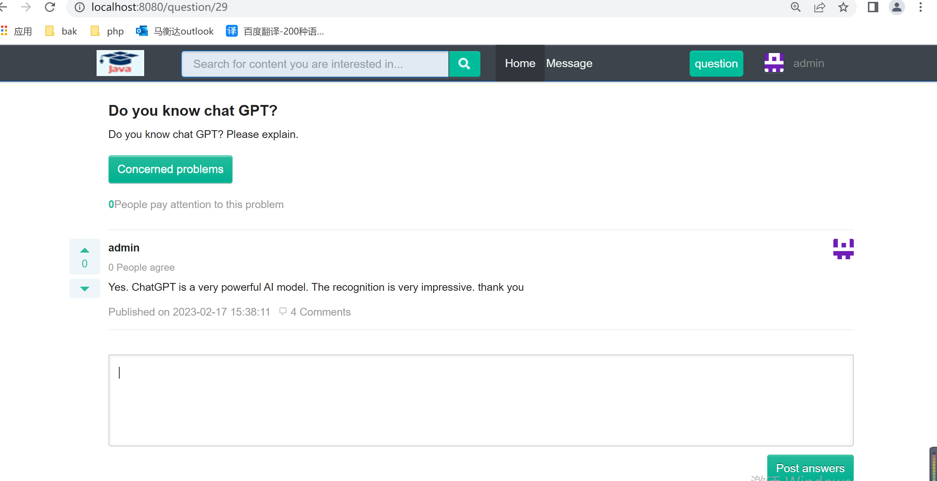

5.5The screenshot of the logout implementation is as follows:

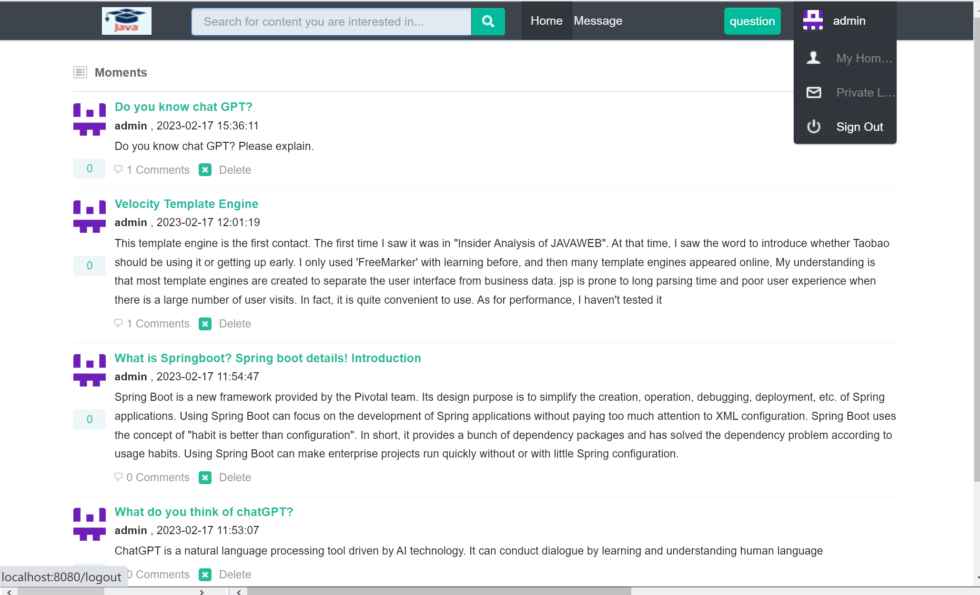5.6 Just look at the implementation of your problem. The screenshot is as follows
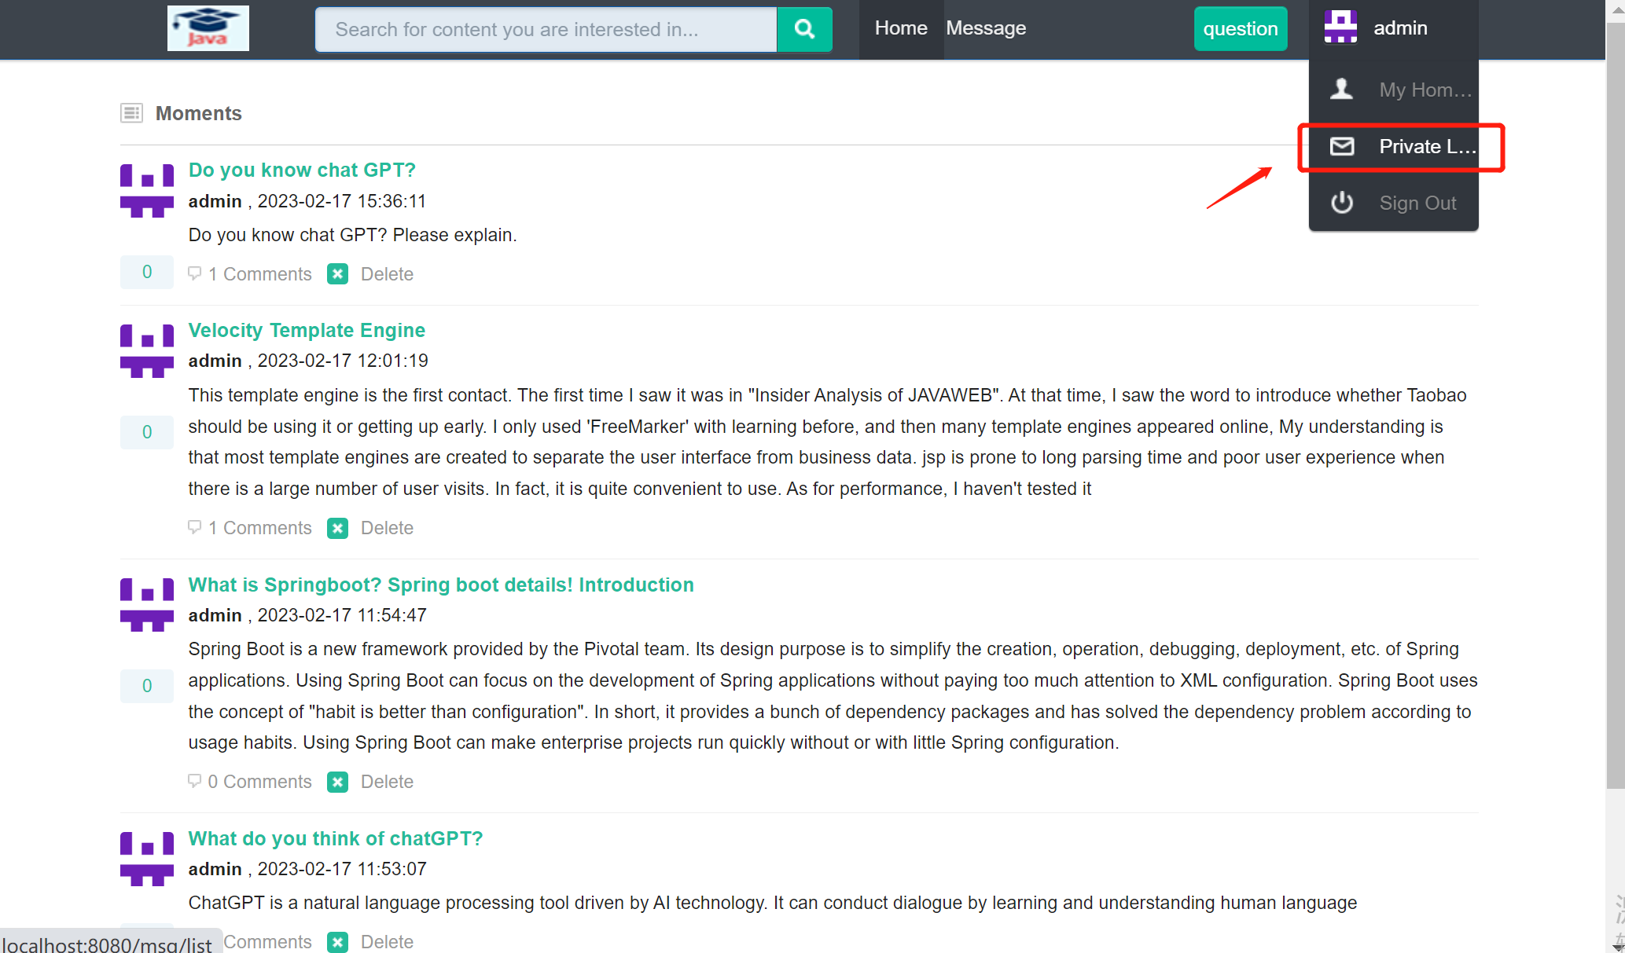

Chapter V Performance Test
The so-called system test is the process of executing a program to find errors in the program [10].
In the process of designing the system, it is inevitable that there are some mistakes. For syntax errors of statements, they are automatically prompted when the program is running and requested to be corrected immediately. Therefore, such errors are relatively easy to find and correct. However, another type of error is the error result caused by incorrect operation or logical error of calculation formula for some data during program execution. This kind of error is highly hidden, sometimes occurs and sometimes does not occur. Therefore, it is time-consuming and laborious to troubleshoot this kind of dynamic error.
(1) The importance of testing
Software testing plays an important role in the software life cycle. In the traditional waterfall model, software testing is only before the operation and maintenance stage. It is an important means to ensure software quality before software certification and the realization of remote real-time monitoring and delivery of oil pump to users. Recently, the software engineering community has tended to a new view that testing should be included in each stage of the software life cycle, so as to check whether the results of this stage are close to the expected goals, and to find and correct errors as early as possible. If testing is not conducted at the early stage, the delay and diffusion of errors will often lead to great difficulties in the final product testing.
In fact, for software, no matter what technology and method is used, there will still be mistakes in software. Adopting new languages, advanced development methods and perfect development process can reduce the introduction of errors, but it is impossible to completely eliminate the errors in the software. These introduced errors need testing to find out, and the error density in the software also needs testing to estimate.
(2) Purpose of the test
If the purpose of the test is to find as many errors as possible, then the test should be directed at the more complex parts of the software or the places where there have been more errors in the past.
① Software testing is the process of executing programs to find errors;
② The purpose of testing is to prove that the program is wrong, not to prove that the program is error-free;
③ A good test case is that it can find errors that have not been found so far;
④ A successful test is one that has found errors that have not been found so far.。

（2）Purpose of the test
If the purpose of the test is to find as many errors as possible, then the test should be directed at the more complex parts of the software or the places where there have been more errors in the past.
① Software testing is the process of executing programs to find errors;
② The purpose of testing is to prove that the program is wrong, not to prove that the program is error-free;
③ A good test case is that it can find errors that have not been found so far;
④ A successful test is one that has found errors that have not been found so far。

6.1 Research and selection of test cases
The main methods of program testing are divided into two categories, white-box testing and black-box testing. The test of the community question and answer (CQA) system integrates two methods: white box test and black box test, but the black box test method is mainly used.
6.2 Test environment and test conditions
Processor: Inter Core2 I7
Memory: 8G
Hard disk: 512G
Operating system: Windows 7
Database: mysql5.7
Java server: JDK1.8

6.3 Example test
Test purpose:
Detect the function of "authentication and login/question/answer/view information"。
Actual test results:
Achieve the expected results.

6.4 Test Summary
The test of this CQA system is mainly to test the user login function, CQA file function, scheduling function, etc.
(1) User login function
(2) Community question and answer (CQA) function
(3) Query function
After the above tests and correction of errors, all functions of the CQA system can be operated according to the design requirements。

Chapter VI Conclusion
Through the design, code writing, and testing of the community question and answer (CQA) system, the community question and answer (CQA) system has reached the expected functional requirements and can complete the basic functions.

Thank you

